

**USMAN INSTITUTE OF TECHNOLOGY**

**Department of Computer Science**

**CS311 Introduction to Database**

**Spring 2023**

# **Lab # 12** Order Management System (Putting All together)

**Objective:**

.

|  |
| --- |
| MAIRA USMAN |

**Name of Student:**

|  |  |  |
| --- | --- | --- |
| 21B-011-SE | **Section:** | **B** |

**Roll No:**

|  |
| --- |
| 26-June-2020 |

**Date of Experiment:**

|  |
| --- |
|  |

**Date Submitted:**

Marks Obtained/Remarks: _____________________________

Signature: __________________________________________

## Order Management System

1. Create a table having name as **your full name_ITEM. (ITEMS)** 
   1. Table should have the following columns:
      1. Item ID Integer (primary key, not null & generated with sequence)
      2. Item Code Varchar2
      3. Item Name Varchar2
      4. Item Price Number
      5. Item Qty Number
2. Create another table having name as **your first name _Order (ORDER)**
   1. Table should have the following columns:
      1. Order_ID Integer(primary key & not null)
      2. Cus_ID Integer (Foreign Key)
3. Create another table having name as **your first name_ORDER_Detail (ORDER_ITEM)**
   1. Table should have the following columns:
      1. Order_detail_id Integer (primary key & not null)
      2. Order ID Integer (Foreign Key)
      3. Item ID Integer (Foreign Key)
      4. Order Qty Integer
      5. Order Price Integer
      6. Order_Sub_total Integer
4. Create another table having name as **your first name _Customer (Customer)**
   1. Table should have the following columns: 
      1. Cus_id Integer (primary key & not null)
      2. Cus_name Varchar2
      3. Cus_Address Varchar2

**Customer**

**Orders:**

**Order Details:**

**Items:**

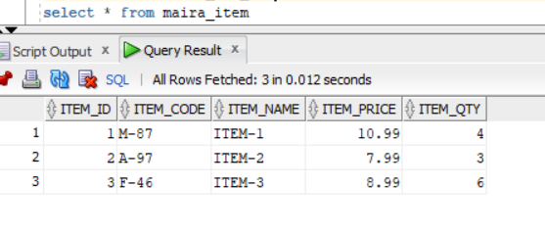

## Student Tasks

1. Create the above 4 tables including all constraints
2. Insert some rows in all tables as order by a customer for particular item(s).
3. Write a query to show all orders with respect to customers (Use Group By)

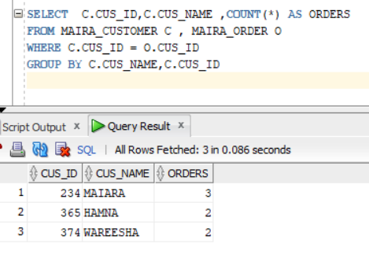

1. During the insertion in ORDER_ITEM (3rd Table) table, if order quantity is not available or less, a message should be generated telling the user “Item not available! Or Not in this quantity” (**hint:** create a trigger on insert (Before) in ORDER_ITEM table to check the order quantity should be less then item quantity in ITEMS table)

1. During the insertion in ORDER_ITEM (3rd Table) table, the total should be calculated and update in Order_Sub_total field (**hint:** create a trigger on insert (BEFORE) in ORDER_ITEM table to calculate order price * order qty and store it in Order_Sub_total)

